Recycle your old PC.
Help us help schools in the Philippines
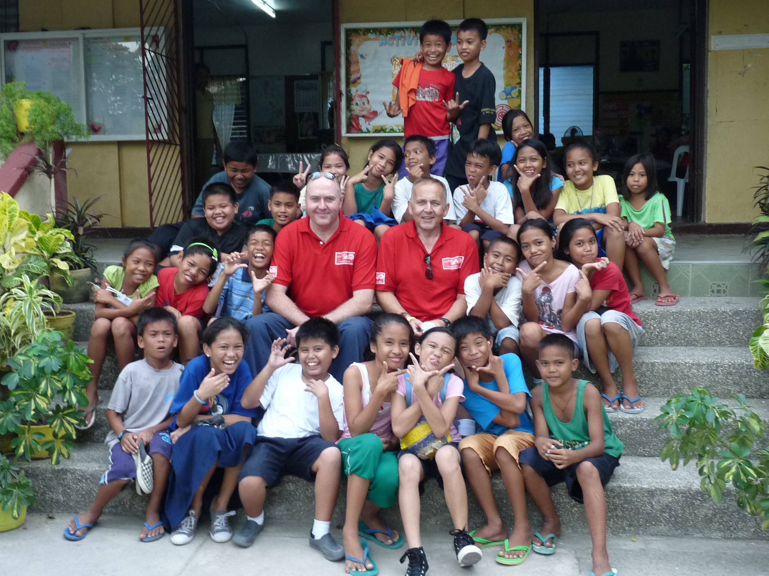
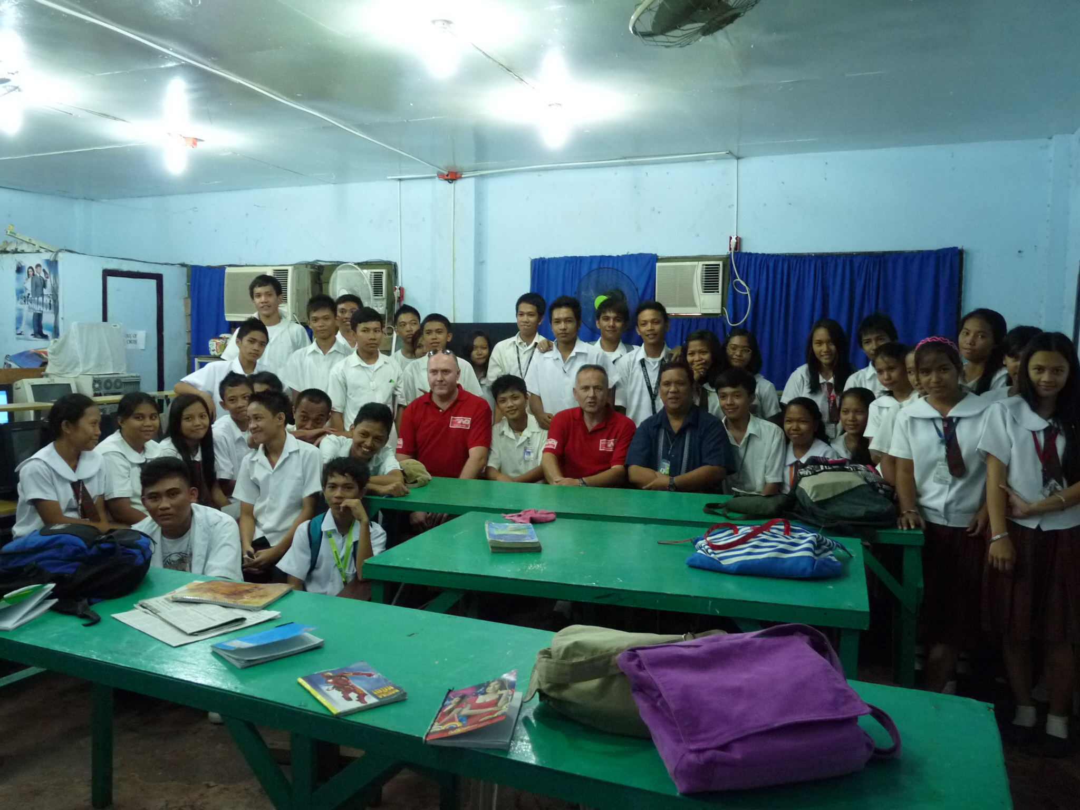
If you have any old PC equipment you do not need anymore, then please consider donating it to the shunters on the day shift at Andover CDC. Our plan is to gather as many PCs and I.T. equipment as possible from donations so we can then kit out several schools in the Philippines with an IT suite each. Your old PC will be revamped, packed and shipped by Norbert Dentressangle to the island of Cebu in March 2013. It will then have a new life as a much loved PC for a school that currently has nothing. A crew from Andover will fly there to fit these on-site in the schools. Any equipment considered. Also games.
For more information contact James and Tim on 0794 6619934 e-mail james.lewis3@bathspa.org

